

Experiment 2

Name of the Student: - Rutuja Rajesh Kini Roll No:- 53

Date of Practical Performed: -28/1/25 Staff Signature with Date & Marks

# Aim: Write a program to perform Client server using RPC/RMI.

**Theory:**

**RPC (Remote Procedure Call)** and **RMI (Remote Method Invocation)** are two popular communication methods used in distributed systems, where a **client** can request services or methods from a **server** as if they were local procedures or methods, even though they may be running on different machines in the network.

1. **Remote Procedure Call (RPC)** - It is a protocol that allows a client to execute a procedure (or function) on a remote server. The client sends a request to the server, which processes it and returns a response. This "remote" interaction is abstracted so the client doesn't have to worry about the details of communication over a network.

## How it works:

* **Client Side**: The client calls a local proxy function that looks like the server-side function. The proxy handles the network communication and sends the request to the remote server.
* **Server Side**: The server listens for requests, executes the requested procedure, and sends back the result.
* **Stubs and Skeletons**: These are intermediary components that facilitate communication between client and server:
  + **Client Stub**: It acts as a local proxy for the server function. When the client calls the remote function, the stub handles marshalling (packing) the arguments, sending them over the network, and returning the response.
  + **Server Skeleton**: It receives the call from the client, unpacks the arguments, calls the actual server function, and sends the result back to the client.

## Example Use Case:

* A **client application** might request data or processing from a **remote server**, like fetching user details or performing a computation.



* **Java RMI** is an example of an RPC-based system.
* When working with **heterogeneous systems** or different programming languages (e.g., Python to Java communication).
* When you need simple **procedure-based** communication.

# Code:

**Server**-

from xmlrpc.server import SimpleXMLRPCServer # Function that the client will call remotely

def add(x, y):

return x + y

# Create an XML-RPC server

server = SimpleXMLRPCServer(('localhost', 8001))

# Register the function so the server can process it server.register_function(add, 'add')

print("Server is running...") server.serve_forever()

# client-

#client code

import xmlrpc.client

# Create a connection to the server

server = xmlrpc.client.ServerProxy(['http://localhost:8001')](http://localhost:8001/)

# Call the remote function to add two numbers result = server.add(6, 5)

print(f"The result of adding two no's: {result}")



# Output:

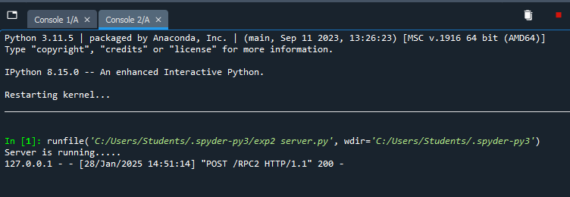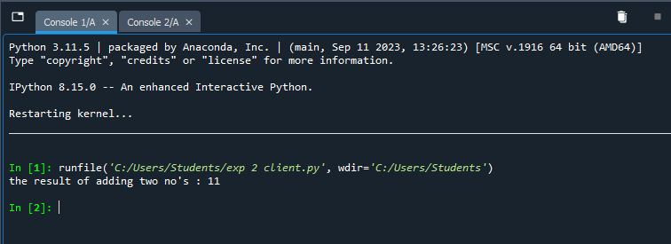

**Conclusion:** Therefore, we have learned and understood communication between client-servers using RPC(Remote Procedure Call).